Breakpoints

Logs

Try - Catch

Timing & Sync Activities

- Element Exists

- Find Element

- Wait Element Vanish

Good Practice: Name specific each step control

In case of an error it will show exactly where it was

Debugging tools are in tab EXECUTE

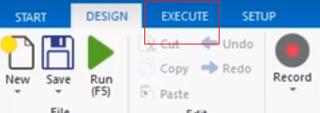

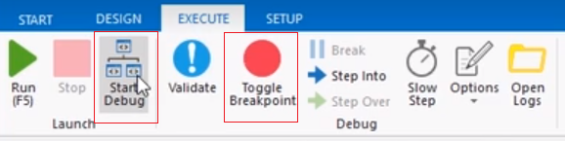

It waits by default 30 seconds, if you set to 0 it will throw an error

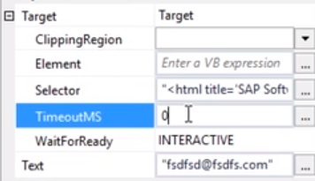

Element Exist

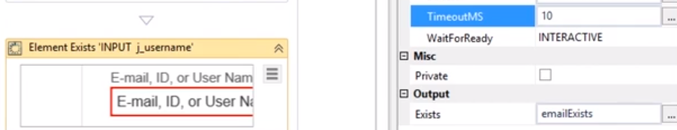

Waits in this case 10 milliseconds, the result will be a Boolean variable emailExists and after you can set and “IF” or “WHILE” or show that the element was not found

FindElement Stops the automation until the element is found. Waits by default 30 seconds

WaitUntilElementVanish Stops the automation until the element disappear. Waits by default 30 seconds

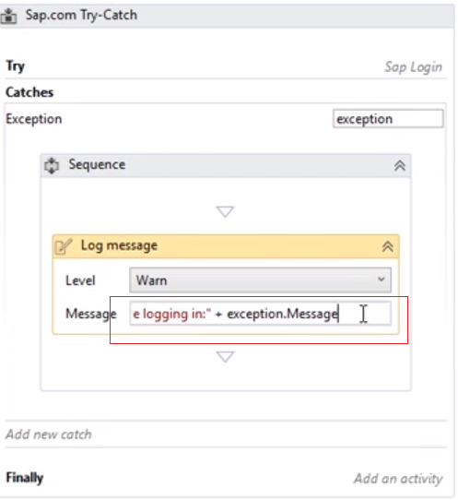

The log is written

